## horizontal line



Instacart -Market Basket Analysis

**─**

Arokia Ajith Leo x  
DMT6-Guvi

# 

# 

# Overview

Maplebear Inc. doing business as Instacart, is an American delivery company based in San Francisco that operates a grocery delivery and pick-up service in the United States and Canada accessible via a website and mobile app.

It allows customers to order groceries from participating retailers with the shopping being done by a personal shopper.

**Project Overview**

To Analyse the Instacart orders Dataset to find customer behavior, product popularity, order patterns, and departmental performance. The dataset includes information from over 3 million grocery orders from more than 200,000 Instacart users. It includes details on the sequence of products purchased, the timing of the orders, and customer reordering behavior.

**Tools Used:**

Power Bi   
SQL Compiler

**Objectives**

The primary objective of this project is to conduct an in-depth analysis of customer behavior within a retail context and strategize marketing initiatives tailored to individual customer preferences and usage patterns. While established campaign Key Performance Indicators (KPIs) and campaign types are prevalent within the retail sector, devising personalized campaigns informed by behavioral data poses a unique challenge. This endeavor aims to investigate and implement effective methodologies for personalized campaign creation based on behavioral insights.

* To Understand Customer Behavior: Analyze ordering patterns to identify customer preferences and reorder frequency.
* Product Analysis: To Determine which products are most popular, and frequently reordered, and identify trends in product sales across different departments and aisles.
* Order Analysis: To Examine the distribution of orders by time of day, day of the week, and interval between orders to understand peak times and purchasing habits.

**Key Business Question**

**1. How many orders by weekdays happen?**

**2. Which products are most ordered?**

**3. Buying pattern of customers**

**4. Which department should be focused on getting new users?**

**5. Which product should be added to the department for more orders?**

## **EDA -Instacart Market Basket Analysis**

**Data Handling:**

The dataset includes information from over 3 million grocery orders from more than 200,000 Instacart users. It includes details on the sequence of products purchased, timing of the orders, and customer reordering behavior. The main files relevant to this analysis are:

Dataset link: <https://drive.google.com/drive/u/0/folders/13LO1RBLfV7h3Wksm-O7dA7XmBAHr7AD3>

* orders.csv: Contains information on each order such as order number, day of week, time of day, and days since the last order.
* order_products__prior.csv and order_products__train.csv: These files provide details on the products purchased in each order, including whether the products were reordered.
* products.csv: Lists product names along with their associated aisle and department.
* aisles.csv **and** departments.csv**: Provide metadata about product categorizations.**

# Power Bi:

Power Bi is used for EDA Analysis and visualization for business insights and recommendations for this project.

**Dashboard Overview:**

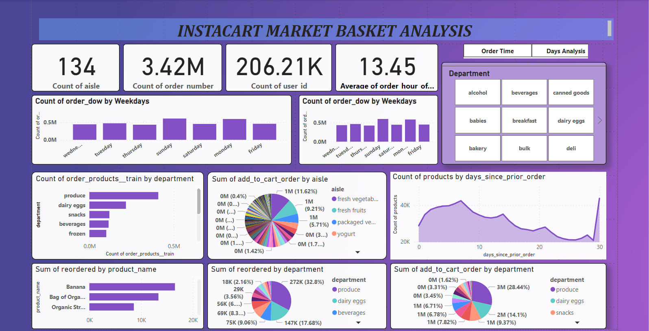

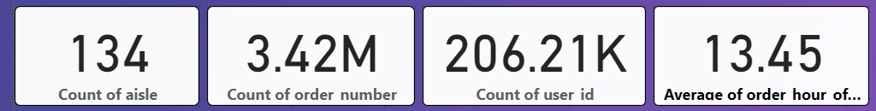

* The overview of the data represents there are 134 aisles,3.42M orders, and 206.21k users.

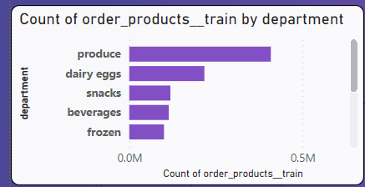

* In **"produce"** department demonstrated the highest count of order_products__train, surpassing "dry goods pasta" by 956.72%. The latter recorded the lowest count at 38,713.
* **"Produce"** represented **33.56%** of the total count of order_products__train.
* Across all 10 departments, the count of order_products__train varied between 38,713 and 409,087.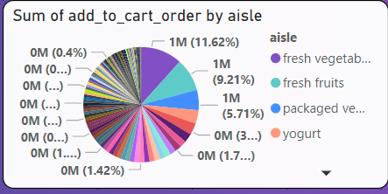

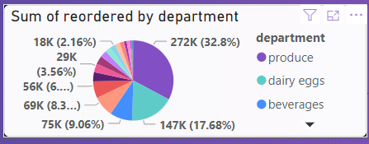

* Fresh vegetables constituted 11.62% of the aggregate sum of add_to_cart_order.
* The highest order, accounting for 32.8%, was recorded in the 'Produce' department. Within this department, both 'reordered' and 'add to cart' actions were recorded.
* Specifically, 'add to cart' accounted for 28% of the activity in the 'Produce' department. The 'Produce' department contains fruits, with fresh vegetables being the most ordered item."

**Products by days Analysis**

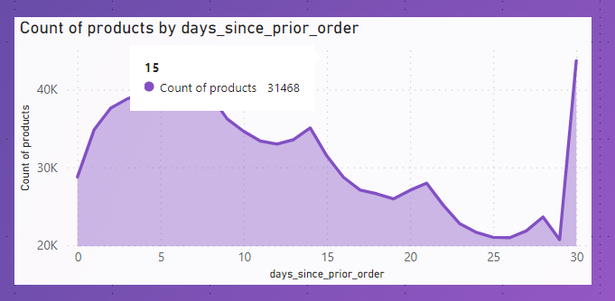

* On Sunday, it accounted for 17.56% of the count of order_dow. With a count of 600,905, Sunday had the highest count of order_dow, which was 40.95% higher than Thursday, the day with the lowest count of order_dow at 426,339.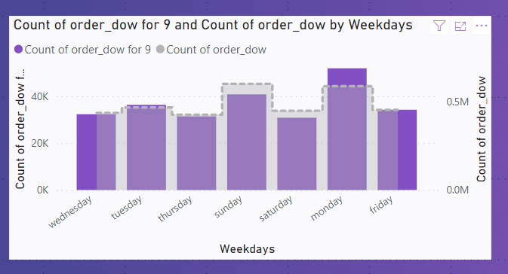
* Across all seven weekdays, the count of order_dow ranged from 426,339 to 600,905.

**Order By Time Analysis**

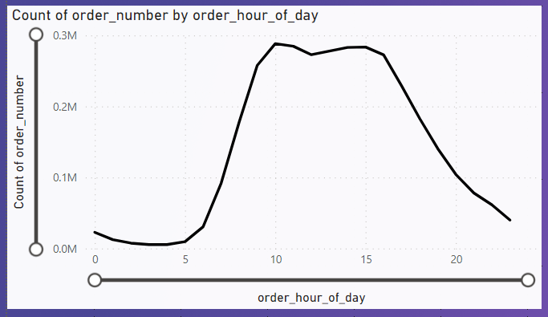

* The most ordered times between  ***10.00 A.M to 1.00 P.M*** exhibited the highest count, which recorded the lowest count at 5,474, by a margin of 5,168.87%.
* Furthermore, orders at 10.00 A.M accounted for 8.43% of the total count of order_number.
* Across all 24 order_hour_of_day segments, the count of order_number ranged from **5,474 to 288,418.**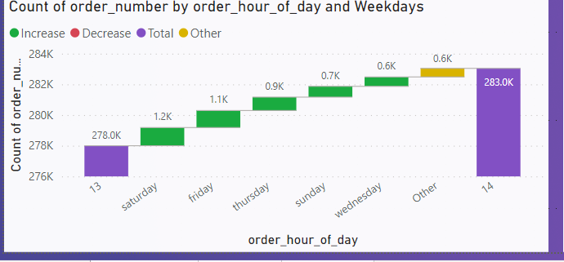
* The most ordered times between  ***1.00 P.M to 2.00 P.M*** exhibited the highest count, increased day by day from Saturday to Wednesday.
* The increased ordered times between  ***6.00 A.M to 7.00 P.M*** exhibited the highest count. Monday Accounted most increased ordered items followed by Sunday.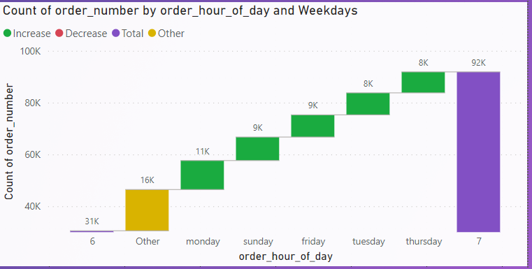

**Findings & Recommendations:**

* After EDA analysis Instacart found that in the “ produce” department which accounts for most reordered by the department 50% of users from this department make “add to cart “ items are more. Instacart makes attention to create more visibility of the second most ordered department-” dairy products”.
* The most preferred time by users is from 10.00 A.M to 12.00 P.M, sending pop-up notifications of new line products from these departments makes users increase their orders.
* On Sundays only accounts for more orders when compared with other days. Instacart can create time-based campaigns according to the days of the week and hours of the day. For instance, night orders are low every weekday. Also, orders are decreasing when we close to the end of the week like Friday and Saturday.

**Conclusion:**

* The daily essentials category stands out as the most frequently purchased product group, reflecting a significant share in both weekly reorder patterns and overall product sales. Considering this trend, implementing targeted, time-limited promotional campaigns tailored for customers who regularly make monthly purchases within these categories could be a strategic initiative for the company.
* Based on the dataset, it appears that consumers tend to prioritize adding urgent or essential items to their carts before exploring additional products. Enhancing recommendation performance could lead to a higher number of orders over the long term by effectively guiding customers towards complementary or supplementary items during their browsing journey.
* Time-limited campaigns have shown the potential to boost order volume. Analysis of the dataset reveals a comparatively smaller share of orders during night and evening hours. Leveraging profitability analysis, the company could strategically introduce time-limited campaigns tailored for these periods, potentially maximizing revenue during less active times.